Magical Beginnings Camo Hoodie Order form
All proceeds to benefit the
Skip and Shirley LaBrie Schoalrship Fund
Unisex Lightweight Hooded Pullover Sweatshirt $40
80% cotton 20% polyester

Full Length
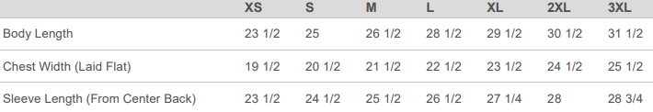
Cropped
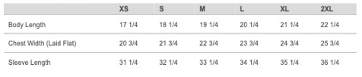
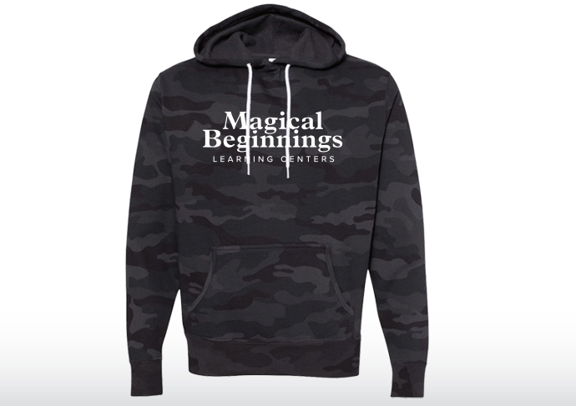

Full length: ____XS ____S ____M ____L ____XL ____2XL ____3 XL
Cropped: ____XS ____S ____M ____L ____XL ____2XL ____3 XL

Name: ____________________________________________
Phone: _________________ Email: _____________________________
School: __________________________________

Paid By: Cash Check Amount enclosed: _____________

All orders, with payment, due by Friday 8/27.
Please make checks payable to: The Skip & Shirley LaBrie Scholarship Fund
Estimated delivery October 1st

