Magical Beginnings Logo Hoodie Order Form
All proceeds to benefit the
Skip and Shirley LaBrie Scholarship Fund
Unisex Lightweight Hooded Pullover Sweatshirt $40
80% cotton 20% polyester
Full Length
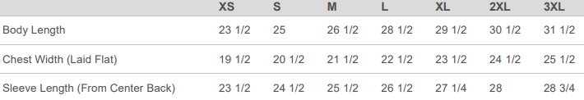

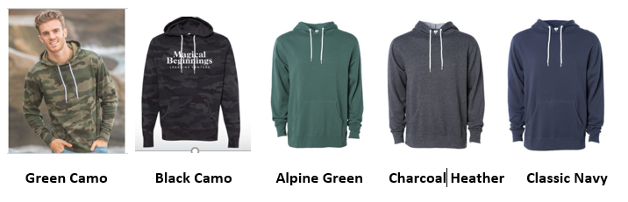
(Cropped available in black camo only XS – 2XL)
Color: _________________ Size: __________
Color: _________________ Size: __________

Name: ____________________________________________
Phone: _________________ Email: _____________________________
School: __________________________________

Paid By: Cash Check Amount enclosed: _____________

All orders, with payment, due by Wednesday December 1st.
Please make checks payable to: The Skip & Shirley LaBrie Scholarship Fund

