Port & Company Toddler Core Fleece Pullover Hooded Sweatshirt. 50/50 cotton/poly fleece No drawcord at hood
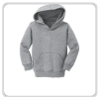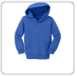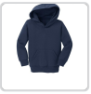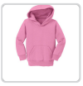
Athletic Heather Royal Navy Candy Pink
2T, 3T, 4T
PRODUCT MEASUREMENTS
 | 2T | 3T | 4T
Chest Width | 13 1/2 | 14 | 14 1/2
Body Length at Back | 15 1/2 | 16 1/2 | 17 1/2
Sleeve From Shoulder | 18 | 19 | 20
$32 each
Color: _________________ Size: __________
Color: _________________ Size: __________
Color: _________________ Size: __________

Parent/Guardian Name: ____________________________________________
Phone: _________________ Email: _____________________________
School: __________________________________

Paid By: Cash Check Amount enclosed: _____________

All orders, with payment, due by Wednesday 12/1.
Please make checks payable to: The Skip & Shirley LaBrie Scholarship Fund

